## Relative Dating Practice

**Purpose:** In this activity you will learn to determine the sequence of geologic events from cross sections of strata (rocks) in a given area.

**Background:** Before absolute dating of rocks was developed in the 20th century, geologists had to rely on relative age dating, which places geologic events in their order of occurrence. The method begins with the careful drawing and description of strata (the geologic cross section or profile). Relative age dating assumes that the lower layers in any particular cross section are older than the upper layers in that cross section (“the law of superposition”) and that an object cannot be older than the materials of which it is composed.

**How?** In this process, you will study the rocks and events in a geologic cross section and put them in the correct order from oldest to youngest. In order to do your best on this activity, you must understand a few of the basic principles that are applicable to relative age relationships between rocks: (you do not need to know these terms but they can help you determine the correct order of the layers)

* **Principle of superposition:** in a sequence of undeformed sedimentary rocks, the oldest beds are on the bottom and the youngest are on the top.

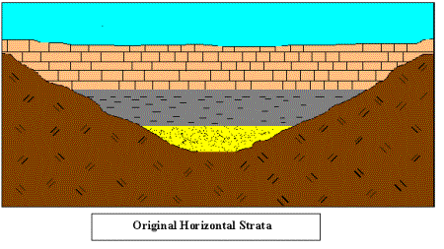

* **Principle of original horizontality:** sedimentary layers are horizontal, or nearly so, when originally deposited. Strata that are not horizontal have been deformed by movements of the Earth’s crust.
* 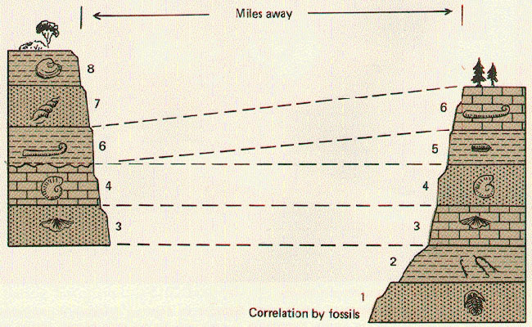**Principle of faunal succession:** groups of fossil plants and animals occur in the geologic record in a definite and determinable order. A period of geologic time can be recognized by its respective fossils.
* 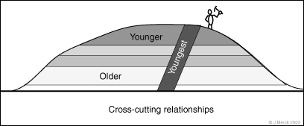**Principle of crosscutting relations:** geologic features, such as faults, and igneous intrusions are younger than the rocks they cut.
* **Principle of inclusion:** a rock body that contains inclusions of preexisting rocks is younger that the rocks from which the inclusions came from.
* **Principle of Unconformity:** surfaces called unconformities represent gaps in geologic time where layers were not deposited for a time or else layers have been removed by erosion. More on this principle on the next page.

The easiest way to do relative age dating is to work from oldest to youngest. Try to **find the oldest rock** (usually located near the bottom) in the diagram below and work your way up.

**Unconformity Type:  
  
____________________________**

**Unconformities**

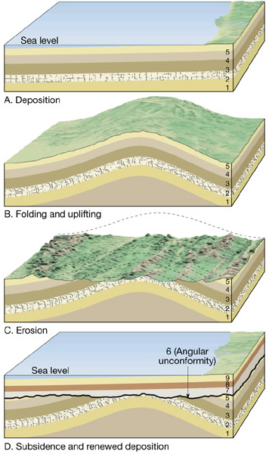

**Angular Unconformity**

An unconformity forms when there’s a break in the rock record. They tell you that rocks of certain ages may not be present at that location. Unconformities **form by rock erosion followed by deposition of new sediment**. Unconformities represent "time gaps" that may be years to hundreds of millions of years in duration (Figure 4). Types of unconformities include:

**Process:**

**__________________**

* **Nonconformity** - Unconformity between sedimentary rocks above and rocks below
* **Angular Unconformity -** An unconformity between horizontal sedimentary rocks above and tilted (deformed) rocks below

**Process:**

**__________________**

* **Disconformity -** Unconformity between horizontal sedimentary rocks above and below

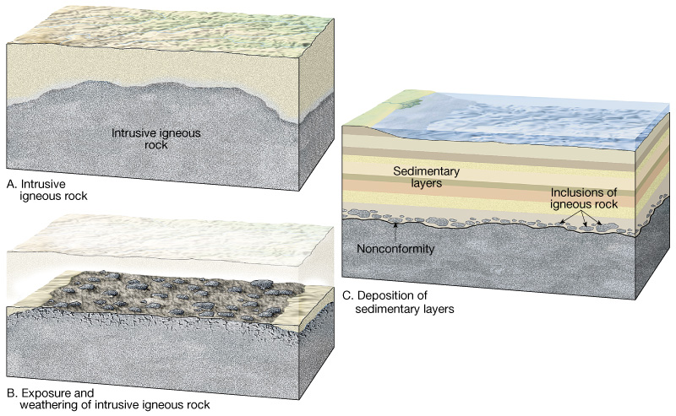

**Unconformity Type:  
  
____________________________**

**_____________**

**__________________**

**_________________**

**Rock Type:**

**Process:**

**New Rock:**

**Process/New Rock:**

**__________________**

**Directions:** For each of the following cross sections, determine the relative age sequence of the rocks. Place the answers in the spaces on the right. Remember, always start by looking for the oldest rock first and working your way from oldest to youngest. Don’t forget to **include all intrusions, foldings and faults**! The diagrams go from simplest to hardest to let you progressively improve your skills.

What kind of rock is rock A?

Youngest ______

______

______

______

Oldest ______

What type of unconformity is between layers E and C?

What’s most likely the type of rock in layer C?

What kind of rock is rock B?

Youngest ______

______

______

______

Oldest ______

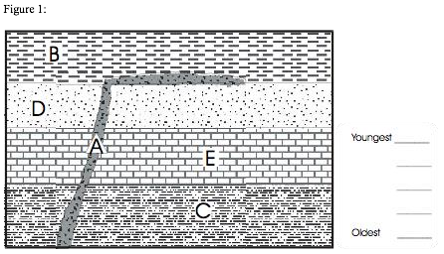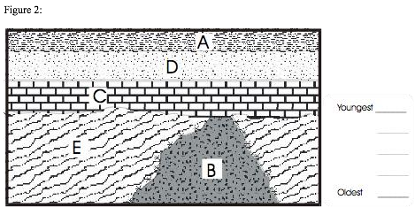

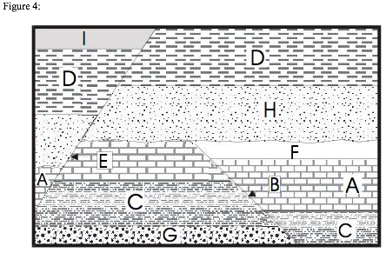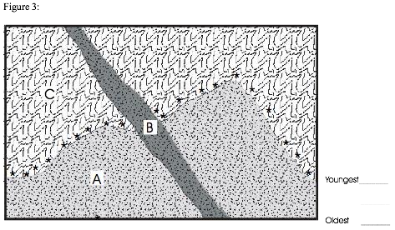

Which happened first, the **fault E** or the unconformity between A and H?

Which happened first, the **fault B** or the unconformity between A and H?

Youngest ______

______

______

______

______

______

______

Oldest ______

What type of rock is A and what do we call this type of rock formation?

Most of C is sedimentary rock. However, what type of rock formed when rock A intruded into rock C? (denoted by ***)

What type of rock is B and what do we call this type of rock formation?

Youngest ______

______

Oldest ______

Figures 5 and 6 are challenges:

1. Create your own lines on the right labeled with “youngest” and “oldest” (make sure to include all layers, faults and folds!)
2. 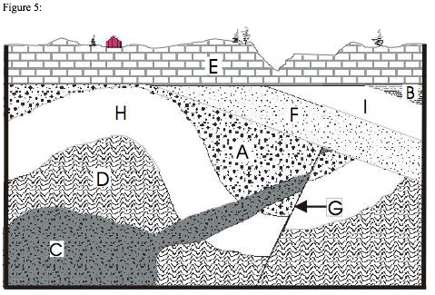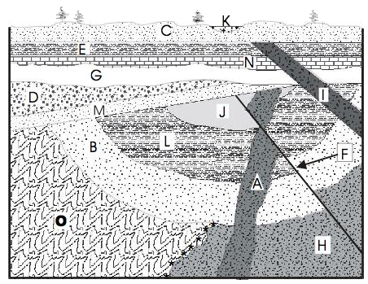Create at least 2 types of questions that you can ask about these layer formations. Get as creative as your can!